How you run a container on production? What if your application relies on other containers such as databases or messaging services or other backend services? What if the number of users increase and you need to scale your application? And, vice versa.

To enable these functionalities, you need an underlying platform with a set of resources and capabilities. The platform needs to orchestrate the connectivity between the containers and automatically scale up or down based on the load. This whole process of automatically deploying and managing containers is known as Container Orchestration.

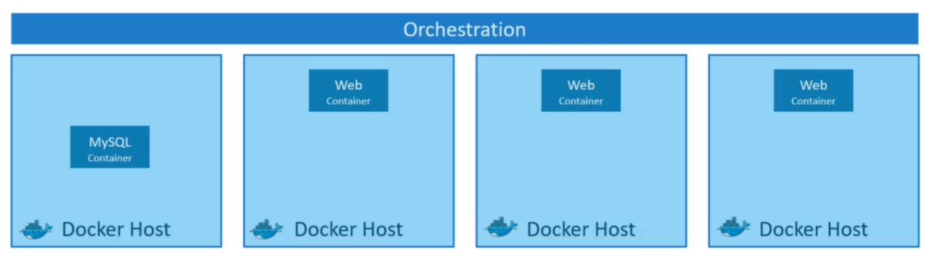

Kubernetes is just a Container Orchestration technology. There are various advantages of Container Orchestration:

1. Your application is now highly available as hardware failures do not bring your application down because we have multiple instances of the application running on different nodes.
2. The user traffic is load-balanced across the various containers. When demand increases, deploy more instances of the application seamlessly within a matter of seconds and we have the ability to do that at a service level.
3. When we run out of hardware resources, scale the number of underlying nodes up or down without having to take down the application and do all of these easily with a set of declarative object configuration files.

